Overview over 5G simulation tool

Problems to consider:

* Multiple users (placement, )
* OFDM?
* FDD/TDD
* Flexibility in resource grid
  + Bandwith/time?
* Collision detection/avoidance
* Connecting to grid
* Bit error rate

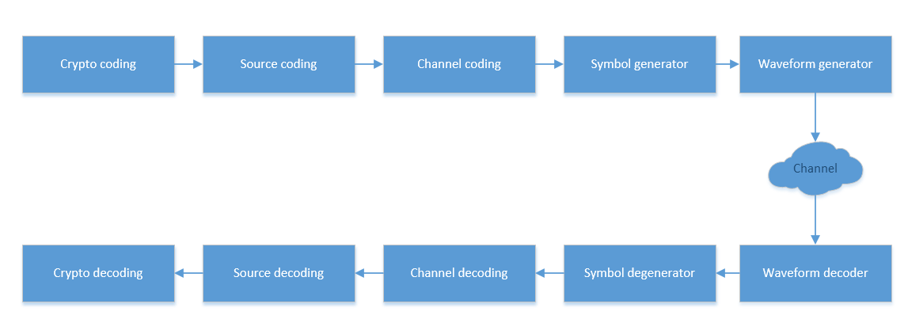

# Crypto coding

Input:

* Data bits
* Crypto scheme
  + Ingen
  + ??
* ??

Output:

* Crypto coded bit stream

Missing info

* Different crypto scheme
* How to evaluate effectiveness
* Measure of goodness

# Source coding

Input:

* Crypto coded bit stream
* Compression scheme

Output:

* Compressed bit stream

Missing info

* How to?

# Channel coding

Input:

* Compressed bit stream
* Channel coding scheme
  + None
  + Turbo code
  + User defined

Output:

* Coded bit stream

Missing info

* Turbo coding scheme

# Symbol generator

Input:



Output:



Missing info

# Waveform generator

Input:



Output:



Missing info

# Channel

Input:



Output:



Missing info

# Waveform decoder

Input:



Output:



Missing info

# Symbol degenerator

Input:



Output:



Missing info

# Channel decoding

Input:



Output:



Missing info

# Source decoding

Input:



Output:



Missing info

# Crypto decoding

Input:



Output:



Missing info